**REACT**

**Hands On – 5**

Create a React App named “bloggerapp” in with 3 components.

1. Book Details
2. Blog Details
3. Course Details

Implement this with as many ways possible of Conditional Rendering.

App.js

import React, { useState } from 'react';

import CourseDetails from './components/CourseDetails';

import BookDetails from './components/BookDetails';

import BlogDetails from './components/Blog Details';

function App() {

  const [showCourses, setShowCourses] = useState(true);

  const [showBooks, setShowBooks] = useState(true);

  const [showBlogs, setShowBlogs] = useState(true);

  return (

    <div style={{ display: 'flex', justifyContent: 'center', fontFamily: 'sans-serif', marginTop: '50px' }}>

      <CourseDetails show={showCourses} />

      <BookDetails show={showBooks} />

      <BlogDetails isVisible={showBlogs} />

    </div>

  );

}

export default App;

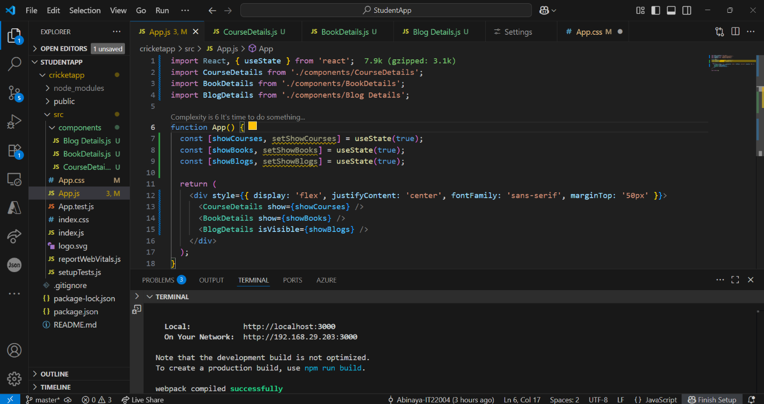

BookDetails.js

import React from 'react';

const BookDetails = ({ show }) => {

  const books = [

    { title: 'Master React', price: 670 },

    { title: 'Deep Dive into Angular 11', price: 800 },

    { title: 'Mongo Essentials', price: 450 },

  ];

  return show ? (

    <div style={{ marginRight: '50px', borderLeft: '3px solid green', paddingLeft: '20px' }}>

      <h2>Book Details</h2>

      {books.map((book, index) => (

        <div key={index}>

          <h3>{book.title}</h3>

          <p>{book.price}</p>

        </div>

      ))}

    </div>

  ) : null;

};

export default BookDetails;

BlogDetails.js

import React from 'react';

const BlogDetails = ({ isVisible }) => {

  const blogs = [

    {

      title: 'React Learning',

      author: 'Stephen Biz',

      content: 'Welcome to learning React!',

    },

    {

      title: 'Installation',

      author: 'Schwezdenier',

      content: 'You can install React from npm.',

    },

  ];

  // Conditional Rendering - Using if condition inside function

  if (!isVisible) return null;

  return (

    <div style={{ borderLeft: '3px solid green', paddingLeft: '20px' }}>

      <h2>Blog Details</h2>

      {blogs.map((blog, index) => (

        <div key={index}>

          <h3>{blog.title}</h3>

          <strong>{blog.author}</strong>

          <p>{blog.content}</p>

        </div>

      ))}

    </div>

  );

};

export default BlogDetails;

CourseDetails.js

import React from 'react';

const CourseDetails = ({ show }) => {

  const courses = [

    { name: 'Angular', date: '4/5/2021' },

    { name: 'React', date: '6/3/20201' },

  ];

  return ( show && (

      <div style={{ marginRight: '50px' }}>

        <h2>Course Details</h2>

        {courses.map((course, index) => (

          <div key={index}>

            <h3>{course.name}</h3>

            <p>{course.date}</p>

          </div>

        ))}

      </div>

    )

  );

};

export default CourseDetails;

**Output:**

